**National University of Computer & Emerging Sciences**

**Karachi Campus**



**Unit Converter Program in C**

**Project Proposal**

**Programming Fundamentals**

**Section: BSE-1A**

**Group Members:**

**23K-3032 Shah Hunain**

**23K-3041 Abdul Hadi**

**23K-3008 Yasbah Ali**

**Unit Converter Program in C**

**Introduction**

The aim of this project is to create an efficient unit converter program in the C programming language. The motivation behind selection of this project is to provide a tool that allows the users to counter complexity and easily convert between various units in different measurement categories.

**Background**

In the modern world, unit conversion is a common requirement in many fields, from engineering and physics to everyday tasks. Especially, students find tackling with various units a hard task. This project was selected to address the need for a flexible and user-friendly unit converter.

**Project Specification**

The project involves the development of a console-based unit converter program in C. The program supports conversion across multiple categories, including length, mass, time, temperature, area, volume, speed, acceleration, force, angle, and frequency.

**Problem Analysis**

The need for a unit converter arises due to the diversity of measurement units. Manually converting between units can be time-consuming and error-prone, especially when dealing with complex conversions. This program aims to tackle the complexities.

**Solution Design**

* **Project Detail**

The project consists of a modular design with separate functions for each unit category. The user interacts with the program by selecting a category, then choosing the unit user wants to convert and then entering the values to be converted.

**Functionality and Features**

* Menu-based user interface for selecting unit categories.
* Specific functions for each unit category with input validation.
* Seamless navigation between different unit conversions.
* User-friendly prompts and outputs for enhanced usability.

**Implementation and Testing**

The program is implemented in the C programming language, utilizing various datatypes, escape sequences, arithmetic operators, functions, loops and break statements, if-else statements, arrays and switch statements for modularity. Extensive testing is conducted to ensure accurate and reliable conversions. The program is designed to handle invalid inputs gracefully.

**Project Breakdown Structure**

* **Workload Distribution with Timeline**

1. Week 1: Research and design, implementation of core functionality
2. Week 2: Testing and bug fixing
3. Week 3: Final adjustments and documentation

**Results**

* **Output Screenshots**

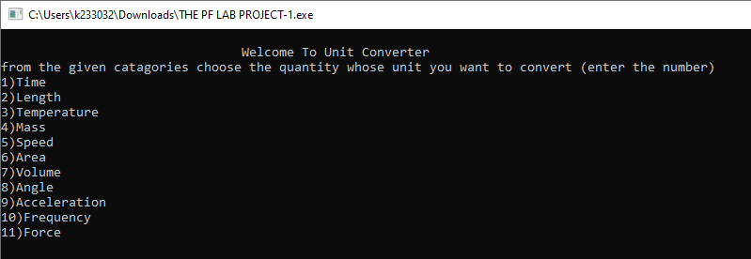

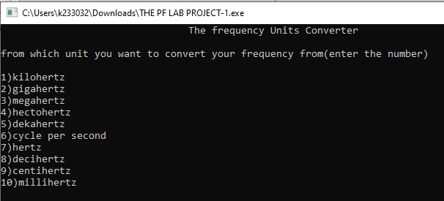

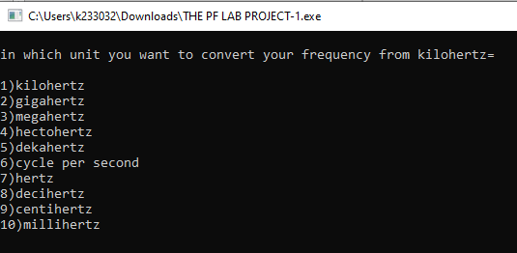

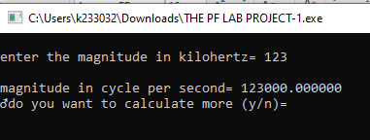

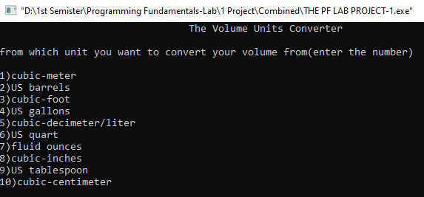

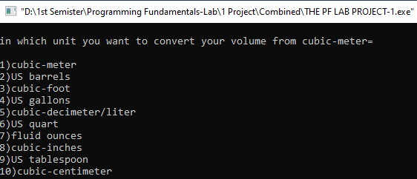

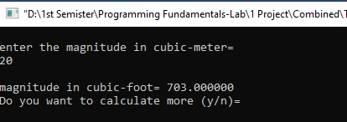

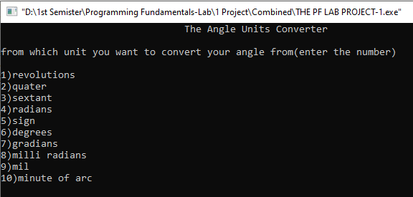

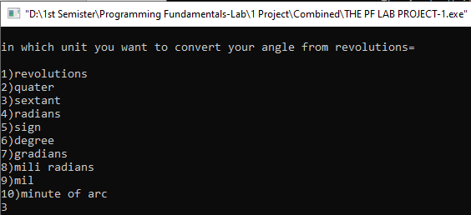

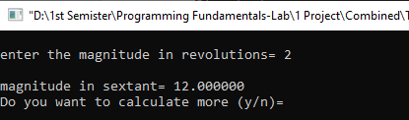

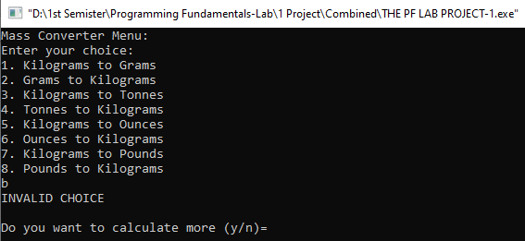

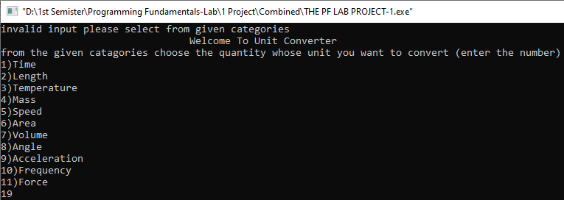

**Conclusion**

In conclusion, the unit converter program in C successfully addresses the need for a versatile and user-friendly tool for unit conversions. The modular design and careful implementation ensure accuracy and reliability in the conversion process.

* **Discussion**

The project provided insights into the challenges of handling different measurement units and the importance of user interface design for efficient interaction. Future enhancements could include additional unit categories or a graphical user interface for improved accessibility.